**IEC 61850 PROTOCOL**

What is IEC 61850?

IEC 61850 is an international standard that defines communication protocols to provide communication between different equipment located in a substation, such as protection, control, and measurement equipment, as well as intelligent electronic devices (IEDs).

The abstract data models defined in IEC 61850 can be mapped to a number of protocols. Current mappings in the standard are to MMS (Manufacturing Message Specification), GOOSE (Generic Object-Oriented System Event), SV (Sampled Values) or SMV (Sampled Measure Values), and soon to Web Services.

Understanding IEC 61850

3 levels are defined by IEC 61850, please note that each level contains different devices:

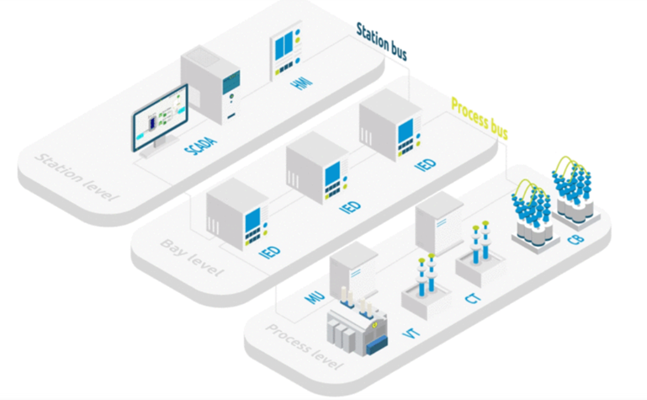

1) PROCESS LEVEL: in this level there are different devices such as switchgears, like circuit breakers, switches, a current transformer, and a voltage transformer.

2) BAY LEVEL: here we can find intelligent electronic devices called IEDs. IEC 61850 defines a process bus to allow communications between IEDs and intelligent instruments and switchgears.

3) STATION LEVEL: contains SCADA and HMI systems; used for substation control and monitoring. Station level uses a station bus to be able to communicate with IEDs located in a bay level.

Communication Protocols of IEC 61850

Although Internet protocol structures provide a secure way of transmitting data, it is slow for real-time systems. That’s why the standard makes the process faster for different protocols for different applications:

1) MMS (Manufacturing Messaging Specification): it is widely used for communication between the IEDs and SCADA system for application, configuration, and monitoring data exchange.

2) GOOSE (Generic Object-Oriented Substation Events): it is used to send messages regarding the status between IEDs. Frequently used for tele-protection tripping.

3) SMV (Sampled Measured Values): provides fast and reliable communication of measurement, protection, and control values of power systems mostly from CT (current transformers) and VT (voltage transformers).

Key Benefits using IEC 61850

1) Assuring communication between multi-vendor equipment avoiding proprietary protocols.

2) Improving visibility of your substation and its assets.

3) Cost effectiveness.

4) Improved configuration and maintenance.

5) Object-oriented representation of data.

6) Easier mapping for third-party applications to access information from multiple IEDs from different manufacturers.

7) Making it easier for application designers so they no longer have to deal with complex representations.

Internet Protocol Structure:

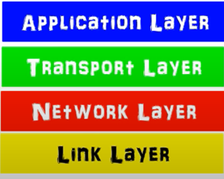

1. Application Layer – Using simple commands to transfer data from one point to another. E.g., world wide web (www) is used by all internet browser to access web page content

2. Transport Layer – In charge to check that all information is delivered correctly.

3. Network layer – Allows data to hop from a different local network through the router.

4. Link layer – To transfer information locally through switches. The internet provides a safe way to transmit data from one point to another (across switches and routers).

However, all these mechanisms are slow for real-time applications, thus, to enable exchange between all devices, IEC 61850 defined 3 protocols of communications:

MMS:

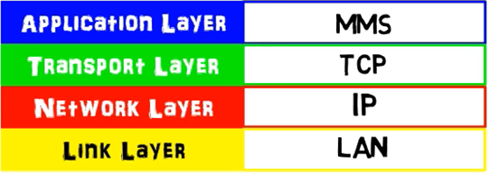

Standard internet application defined by ISO 9506, a client server communication protocol.

The client sends a request to the server and the server sends back an answer (private and secured connection). It is used for communication between the IEDs and SCADA systems.

To give status, make reporting or send control instructions.

GOOSE:

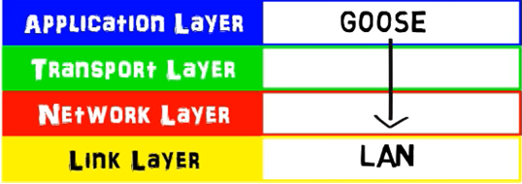

They are used to send urgent messages between IEDs like tripping and blocking, and it replaces hard wiring needed for selective interlocking schemes.

Directly linked to the link layer to deliver quick information in less than 4ms. (Real-time Protocol).

Publisher-Subscriber Mechanism - message is broadcast over the local network to all devices who are listening. It bypasses the transport layer so no acknowledgement. This goose message is urgent thus it is repeated during a certain time with increased frequency (Lost messages due to time lag are analyzed and reported later). It bypasses the network layer too, meaning the goose message cannot hop across the router thus staying in the local area network. Link layer is prioritized, goose messages are given priority by switches.

Easy to configure and reconfigure without rewiring IEDs (1 fiber optic connection is cheaper than 10 copper wires). EMC and EMI sensitivity is reduced. Messages are delivered faster than with wire connection (4ms > 10ms).

SMV:

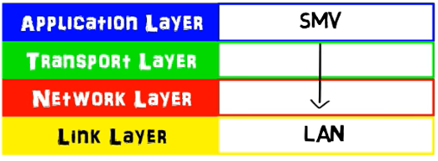

Directly linked to the link layer, uses publisher-subscriber mechanism as well.

SMV allows current and voltage to be sent on a digital way, across the process bus, by a digital instrument or merging unit (transposes analogue signal to digital signal, a discrete value with synchronized time).

This voltage and current measurement can be used by any IEDs which need the information. It does not need additional wiring as it uses the process bus which requires sufficient bandwidth to support the large flow of information.

In medium voltage applications, due to physical proximity between relays and switchgears, it is rarely used today. But the possibility to share voltage and current and the absence of copper wires could be an advantage.

Redundancy Configuration

Real-Time needed for goose and SMV, standard redundancy configuration not applicable. It uses HSR (High Availability Seamless Redundancy) and PRP (Parallel Redundancy Protocol), both methods provide “zero recovery time” with no information lost.

Structure of information

IEC 61850 models all devices and functions in a substation with object-oriented description. Key element is the logical node (smallest part of the function that exchanges data).

E.g., circuit breaker from process level, instantaneous overcurrent protection from bay level, and HMI from station level. Each node contains a number of data.

Circuit breaker – data called pos which represents its position, data attribute which is specified to a parameter, STVAL represents status value of position (closed, open, and intermediate). XCBR.POS.STVAL